**Project Documentation: CRM Application to Make the Gas Filling Station**

**Project Description**

The *Gas Filling Store CRM Application* is a comprehensive tool designed to simplify the gas filling process for customers and store owners. By leveraging the power of Customer Relationship Management (CRM), this project enhances customer experience, streamlines store operations, and boosts the overall efficiency of gas filling stations. The system allows store owners to manage customer relationships, track fuel transactions, and monitor supplier and buyer information, all within a user-friendly interface built on the Salesforce platform.

**Project Goals**

* **Customer Relationship Management:** Streamline customer interaction processes to enhance their experience.
* **Efficiency in Store Operations:** Provide gas stations with a solution to optimize daily operations and improve productivity.
* **Centralized Data Management:** Enable store owners to manage suppliers, customers, and fuel transactions all in one place.
* **User-Friendly Interface:** Develop a simple, intuitive system that reduces complexities for users.

**Milestones and Activities**

**Object Creation:**

* Created **Supplier**, **Gas Station**, **Buyer**, and **Fuel Details** objects to manage essential data.

**Tabs:**

* Created custom tabs for each object to allow easy navigation and data access.

**Lightning App:**

* Developed a **Lightning App** to facilitate seamless access to the various features of the application.

**Fields:**

* Created a **Junction Object** to relate multiple objects.
* Established a **Master-Detail Relationship** between key objects for data connectivity.
* Added a **Number Field** in the Fuel Details object.
* Implemented **Roll-up Summary**, **Formula Fields**, **Cross Object Formula Fields**, **Picklist Fields**, and **Validation Rules** to enhance data accuracy and functionality.

**Page Layouts:**

* Designed user-friendly **Page Layouts** to improve data presentation.

**Profiles:**

* Configured roles with different access levels, including **Manager**, **Sales Executive**, and **Sales Person** profiles.

**Role Hierarchy:**

* Created and implemented role hierarchies for **Manager**, **Sales Executive**, and **Sales Person** roles.

**Users:**

* Created users with various access permissions.

**Permission Sets:**

* Designed and assigned **Permission Sets** to control data visibility and access.

**Setup for OWD (Organization-Wide Defaults):**

* Configured **OWD settings** to define data access levels.

**User Adoption:**

* Verified user adoption through tasks such as creating, viewing, and deleting records.

**Reports:**

* Created a **Report Folder** and configured sharing settings.
* Generated detailed reports on gas filling operations and customer interactions.

**Dashboards:**

* Designed a **Dashboard Folder** and created interactive dashboards for real-time insights.

**Flows:**

* Developed automation through Salesforce **Flows** to streamline key processes.

**Project Status**

As of now, the project is **90% complete**, with the foundational structure and key functionalities already in place. Final adjustments and testing are being performed before the system is deployed for use.

**Deliverables**

**Project Screenshots:**

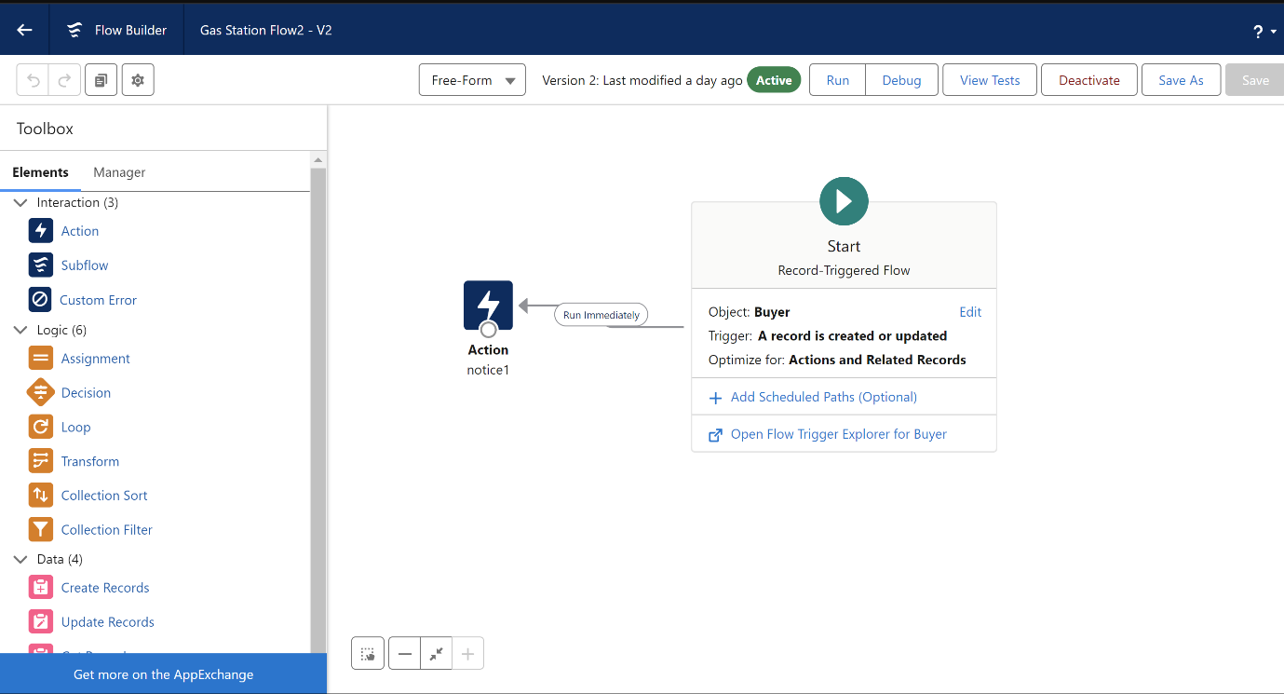

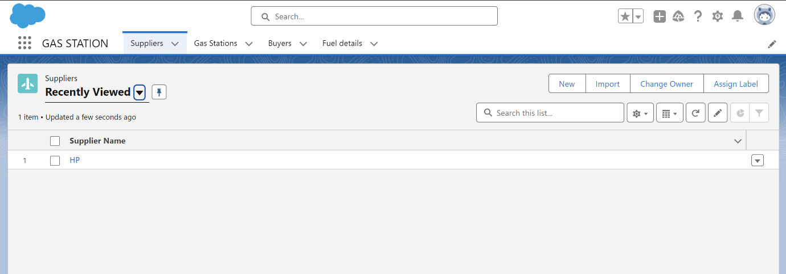

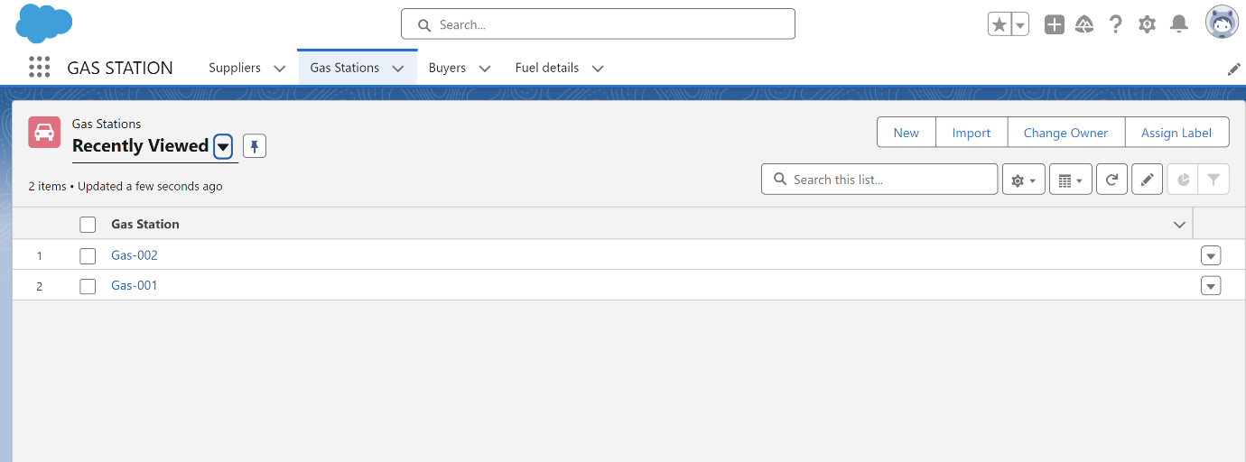

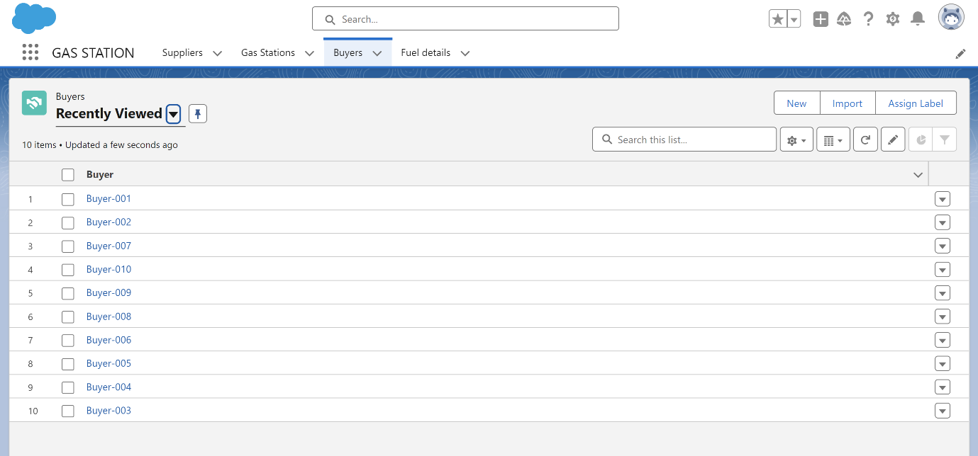

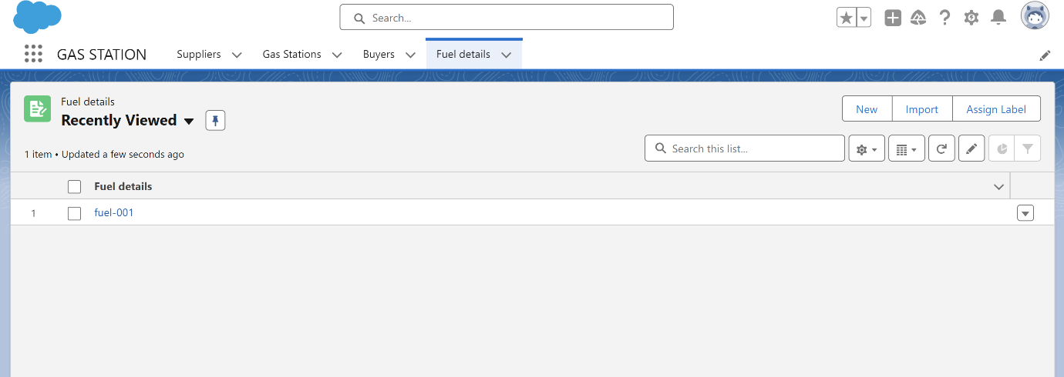

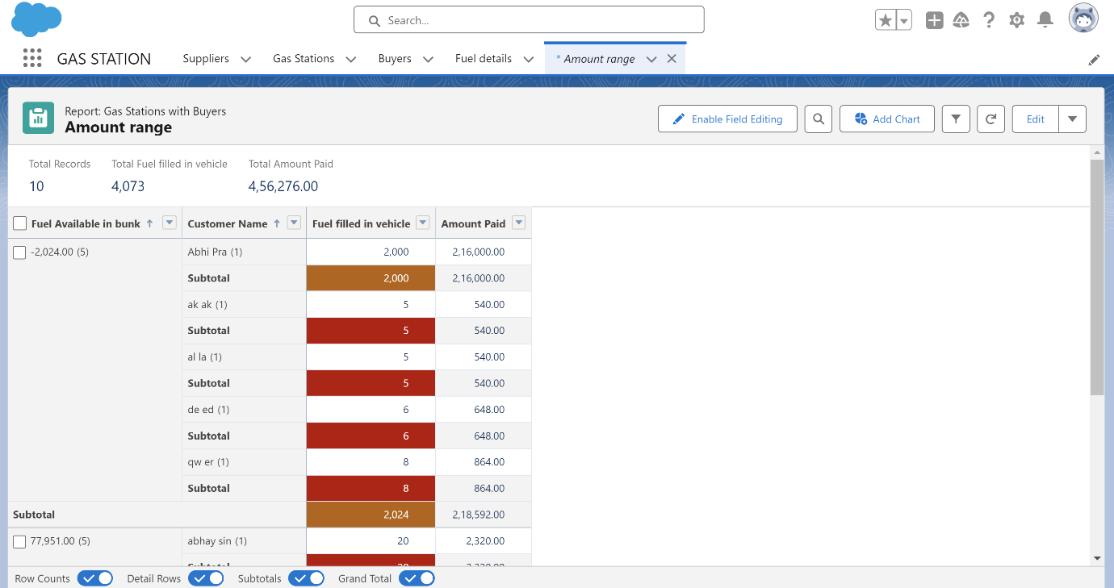

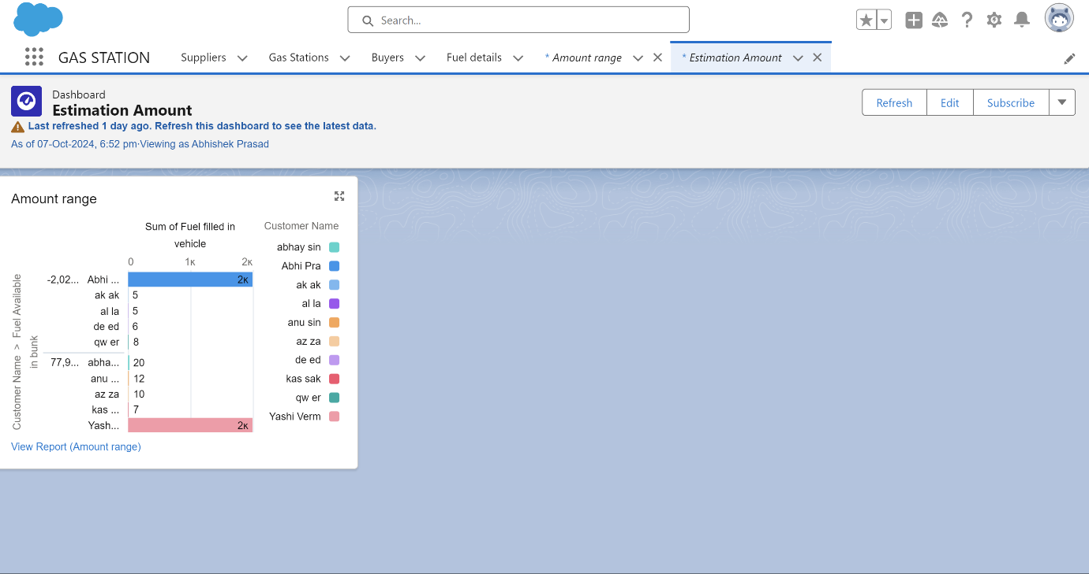

**Project Demonstration Video:** Video Demonstration key feature such as Reports, Dashboards, Flow.

**Video Link:**

**Github Repository**

**Link:**<https://github.com/abhishekpd01/SalesForce-Admin-Project>

**Repository Details:** The Repository contains Output screenshots, Project documentation, Project demonstration video link.

**Mentor Interaction**

**Review Status** **:** The activity card has been moved to the review section. Awaiting final mentor approval.

**References**

**Guide:** [https://skillwallet.smartinternz.com/Student/guided_project_info/6431#](https://skillwallet.smartinternz.com/Student/guided_project_info/6431)

**Conclusion**

The *Gas Filling Store CRM Application* demonstrates the potential of CRM solutions to transform the gas filling industry. It offers a user-friendly, efficient platform for managing customer relationships, fuel transactions, and store operations. With the project nearing completion, it is well-positioned to be a valuable asset for gas filling station owners.